**Software design document**

**Introduction**

The overall goal of Travel Book is to provide users with a convenient and easy-to-use travel check-in and sharing platform, allowing users to record their travel footprints, share travel notes and pictures, challenge players to rank and other functions. The scope of the application includes but is not limited to the client-side application and background management system, the user's travel footprint is recorded through the punch card function, the experience is shared through the publication of travel notes and pictures, and the user's travel enthusiasm is stimulated through the player ranking. At the same time, the background management system can be used to manage user information, statistical data, review pictures, release announcements and other functions.

**Requirement statement**

The app's user requirements include the ability to record travel trips, share travel notes and photos with others, and participate in player rankings. Its functional requirements include tourist attractions punch in, travel notes release, upload pictures, comment function, account registration and login, receive push notifications, etc. In addition, it is also necessary to consider data security and privacy protection, as well as the needs of beautiful and easy-to-use interfaces to improve user experience and user stickiness.

**Overall design**

**Sign up function**

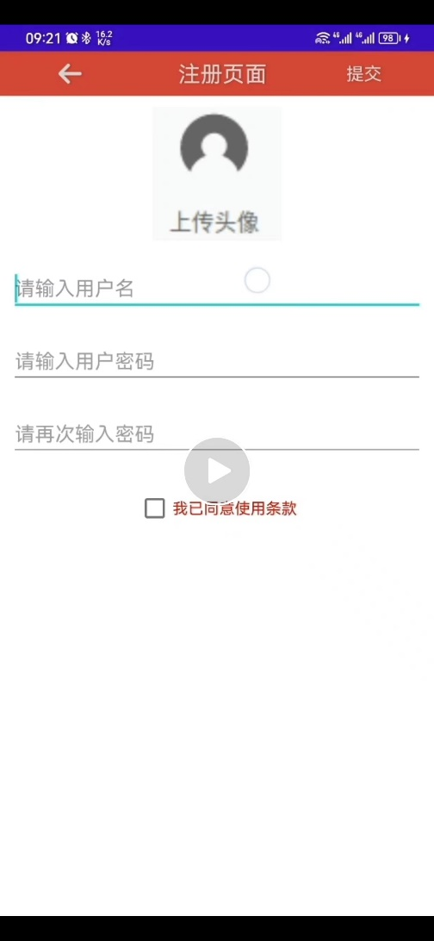

**Login function**

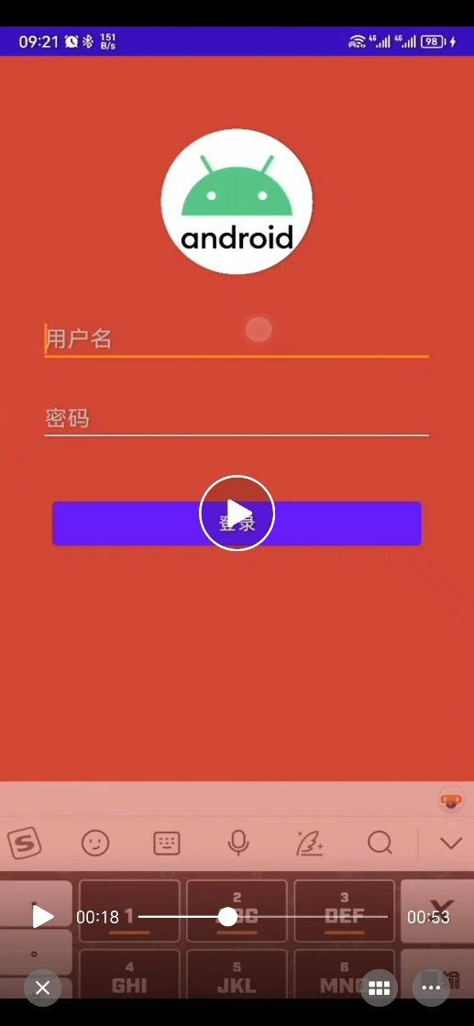

**Post picture function**

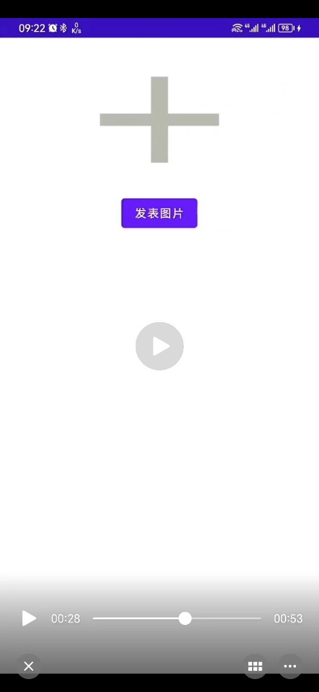

**User interface**

The Travel Book app's user interface is simple and bright, providing intuitive maps, punch buttons, travel travel list and other functions, so that users can easily record their travel footprints, share travel notes and pictures, while also providing social functions such as likes, comments, favorites and other interactive.

**Key technology**

During the development of the Travel Book app, the main technical challenges were: map API access, travel image storage and processing, data security and privacy protection, user experience and interface design. To address these challenges, you need to use a variety of technologies and tools, such as Google Maps apis, Amazon S3 data storage, SSL encryption technology, waterfall stream design, and collaborate with team members to develop development plans and test strategies to ensure application quality and performance.

**Testing and user experience analysis**

The Travel Book application has passed various tests on the third-party cloud platform, including performance test, security test, stability test, etc., without obvious exceptions and errors. The test results show that the application runs smoothly, the response speed is fast and the data security is high. The test team also provided some minor issues and suggestions, which the development team is actively working on and optimizing.

The Travel Book app has received positive feedback from users, who say the app offers useful clock-in, sharing and social functions, as well as a clean and easy-to-use user interface. Users have also provided some improvement suggestions, such as adding a variety of punching and commenting ways, improving the accuracy of search results, etc., and the development team is actively optimizing and improving.

**Conclusion**

With the development of the Travel Book app, we have successfully implemented a practical and user-friendly clocking, sharing and social application. Although we faced challenges during the development process, such as map API access, data privacy protection and other issues, we successfully solved these challenges through the combination of a variety of technologies and tools, and won praise from users. In order to further improve the quality and performance of the application, we plan to add multiple punching methods, improve search engine accuracy, improve data storage efficiency, etc., to ensure user experience and data security.